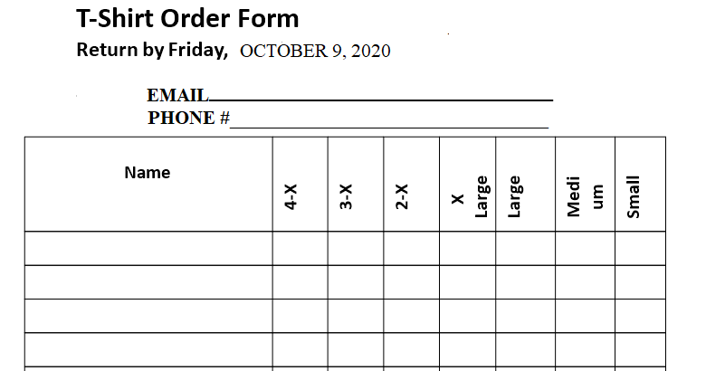

SHIRTS: $15 DONATION